# ISRT Library Management System

Software Requirement and Specification Analysis

Course Code: SE 2206

Submitted By:

Group 3

Noshin Tabassum Dina – BSSE 1503

Md. Rony Rahman – BSSE 1509

Md. Asad Al-Mahmud Fahim- BSSE 1515

Ruzhan Reaz Suham – BSSE 1522

Sabbir Ahmed – BSSE 1530

Submitted To:

Dr. Kazi Muheymin-Us-Sakib

Professor



**Institute of Information Technology**

**University of Dhaka**

Contents

ISRT Library Management System 1

1. Inception 5

1.1 Identify All Stakeholders: 5

1.2 Understanding the Existing System 5

1.2.1 Existing System 5

1.2.2 Observations & Problems in the Existing System: 6

2. Elicitation 8

2.1 Quality Function Deployment (QFD) 8

2.1.1 Normal Requirements 8

2.2.2 Expected Requirements 8

2.2.3 Exciting Requirements 9

3. User Story: 10

4. Use Case Diagram 14

Level 0: 15

Level 1: 16

Level 1.1: 18

Level 1.2: 20

Level 1.3: 22

Level 1.4: 24

Level 1.4.1: 25

Level 1.4.2: 26

Level 1.5: 27

Level 1.6: 28

5. Activity Diagram 29

Level 1.1: 29

Level 1.2: 31

Level 1.3: 32

Level 1.4: 33

Level 1.4.1: 34

Level 1.4.2: 35

Level 1.5: 36

Level 1.6: 37

6. Swimlane Diagram 37

Level 1.1: 38

Level 1.2: 42

Level 1.3: 43

Level 1.4.1: 44

Level 1.4.2: 45

Level 1.5: 46

Level 1.6: 47

7. Data Based Modeling 48

7.1 Data Object Identification 48

7.2 Data Objects: 52

7.3 Relations: 53

7.4 ERD: 54

7.5 Schema: 55

8. Class Based Modeling 58

8.1 General Characteristics 58

Possible Classes: 62

8.2 Selection Criteria: 63

Analysis: 63

8.3 List of Verbs: 64

Selected Classes: 65

8.4 CRC: 70

8.5 CRC Diagram: 75

9. Behavioral Modeling 76

9.1 Introduction 76

9.2 State Transition 76

List of Events: 76

9.2.1 User 79

9.2.2 OTP 80

9.2.3 MFS 80

9.2.4 EmailGenerator 80

9.2.5 Admin 81

9.2.6 Book 81

9.2.7 BPC 82

9.2.8 SummaryGenerator 82

9.3 Sequence Diagram 83

9.3.1 Purpose of Sequence Diagram 83

9.3.2 Sequence Diagram of LMS 84

10. Data Flow Diagram 87

Level 0: 87

Level 1: 88

Level 1.1: 89

Level 1.2: 90

Level 1.3: 91

Level 1.4: 92

Level 1.5: 93

Level 1.6: 94

# 1. Inception

## 1.1 Identify All Stakeholders:

|  |  |
| --- | --- |
| **Stakeholder** | **Role** |
| Librarian | Handles day-to-day tasks like issuing, returning, and cataloging. |
| Typist | Inputs Data |
| Cataloger | Creates and maintains catalog |
| Gatekeeper | Manages entry/exit of users, checks library cards, prevents unauthorized access, and monitors borrowed items at the gate. |
| Teacher | Uses the library for teaching resources, recommends materials, and may request references for students. |
| Technical Officers | Maintain IT infrastructure, digital library systems, OPAC (Online Public Access Catalog), and resolve technical issues. |
| Student | Primary user of the library—borrows books, accesses study materials, uses digital resources, and participates in research. |

## Understanding the Existing System

This section summarizes how the current manual or semi-manual system works and highlights pain points or areas for improvement.

## 1.2.1 Existing System

The ISRT Library currently operates using a combination of manual processes and physical record-keeping systems. The primary components of the existing system are as follows:

#### 🔸 Book Acquisition

* A Book Purchase Committee oversees the procurement process.
* More than 40 books are acquired at a time.
* Bills are manually verified.
* Books are categorized using subject-based codes.

#### 🔸 Registration and Inventory

* Information for ~12,000 books is maintained in a Registration Ledger, including:
  + Title, Author, Classification No, Page No, Publisher, Price, etc.
* If a book is lost, the fine imposed is double its original price.

#### 🔸 Storage and Identification

* Books are stored in cabinets based on classification numbers and subject categories.
* Retrieval relies on the physical identification of books by ID or code.

#### 🔸 Book Issue Process

* ISRT students are issued two library cards each.
* The student must manually fill out the card with:
  + Name, Roll, Department, Book Issue Date, and Due Date.
* A book card is also maintained for each book to track availability and borrower information.

#### 🔸 Budget and Journals

* ISRT uses its own budget to purchase books.
* The library maintains its own research journal, supporting publications by ISRT faculty and researchers.

#### 🔸 Teacher and Staff Rules

* Teachers must notify the library via official letter before borrowing books.
* Teachers/staff must receive library clearance before going abroad or retiring.
* All users (students and staff) must get library clearance before obtaining any certificates/documents.

### 1.2.2 Observations & Problems in the Existing System:

* Manual tracking via cards and ledgers is time-consuming and error-prone.
* No digital search system—users rely on IDs and physical location.
* No notification/reminder system for due dates or fines.
* Fine calculation for lost books is handled manually.
* Data redundancy (both a user card and a book card).
* Reports and analytics are not automated.
* Lack of role-based access control for various users (admin, librarian, member).

# 2. Elicitation

## 2.1 Quality Function Deployment (QFD)

This maps user needs to system functions, helping you prioritize features in the upcoming digital system.

### 2.1.1 Normal Requirements

● A predefined account will be given to the librarian/admin. The administrative account will have access to the central database containing all book records, user data, and borrowing history.  
● The login module will have special accounts for librarians/admins with a separate interface to handle cataloging, issuing/returning books, managing fines, and generating reports.  
● Students, teachers, and staff will provide their personal information to create a user account.  
● The system will show all the currently available books, e-books, and digital resources to the users.  
● The user can borrow, return, or renew physical/digital books based on availability.  
● The user can also request specific resources or customized study material packages (e.g., journals, research papers).  
● The system will allow fines to be paid via MFS. A receipt/invoice will be provided via email after payment.  
● The librarian/admin can manage book inventory, add/remove books, and merge duplicate catalog records.  
● The system must provide insights into student/teacher preferences, borrowing patterns, and most-read subjects.

### 2.2.2 Expected Requirements

● Users should be able to navigate the system effortlessly, without requiring extensive training.  
● The interface should be responsive across various devices (desktop, laptop, tablet, smartphone).  
● The system should provide secure password storage.  
● The system should ensure proper data security and protect sensitive user/book information.  
● A search bar will allow users to search by keywords such as title, author, or subject.  
● Users will have a dashboard showing their borrowing history, fines, due dates, and recommendations.  
● The system should send due date reminders via SMS/email/app notifications.  
● The system should support holiday-aware due dates so that no fines are charged on library holidays.  
● A blacklist mechanism should exist for users who violate library rules or consistently fail to return books.

### 2.2.3 Exciting Requirements

● The librarian/admin can perform advanced search and filtering (e.g., by author, subject, classification number, or user borrowing history).

● The system can generate AI-based book summaries to help users quickly understand content before borrowing/reading.

● A review & rating system allows students and teachers to rate and recommend books, creating a community-driven knowledge hub.

# 3. User Story:

[ The ISRT Library Management System (LMS) is a comprehensive digital platform designed to automate and streamline all library operations at ISRT]

Users begin by selecting their user type—student, teacher, or staff—and registering by providing their full name and phone number. After submitting these, an OTP is sent to their mobile for verification. Once verified, users enter additional role-specific details: students provide roll number, registration number, session, hall name, institutional email, and address; teachers and staff provide designation, official email, and address. After successful validation, users create a unique User ID and Password. Access to a personalized dashboard is granted only after completing all these steps.

Users log in using their user ID and password. First, they must enter a valid user ID. Once the user ID is recognized, they are prompted to enter the corresponding password. If the password is correct, the user successfully logs in.

In case the user forgets their password, a recovery option is available. The system sends a one-time password (OTP) to the phone number associated with the account. Upon verifying the OTP, the user is allowed to reset their password and a confirmation email will be sent to the user.

Upon login, users access their role-specific dashboards. Students and teachers can view their borrowed books, due dates, fines, clearance status, and other personal library activities. They receive notifications via SMS or email regarding upcoming due dates and outstanding fines to ensure timely action. From the dashboard, users can also submit clearance requests whenever needed.

The E-Library subsystem provides a dedicated digital space where all available book PDFs are systematically organized and easily accessible. Users can browse or search for books, and upon selecting a specific title, they are presented with several interactive options. These include downloading the full book PDF, accessing a system-generated summary in PDF format, and participating in the Review & Ratings section. This section features a star-based rating system and allows users to leave written feedback. By offering multiple ways to engage with digital resources, the E-Library subsystem promotes self-paced learning and encourages active user interaction with library content.

The system features a smart search function, enabling users to find books by any detail—such as title, author, or subject—using text or voice input, along with filtering options for refined results.

Users can initiate a book borrowing request directly from their personalized dashboard. The system offers two methods to begin the process. In the first method, users can manually fill out a borrowing form by entering key book details such as the title, author, and classification number. In the second method, users can browse or search for a book through the integrated library catalog. When a book is found, its detail page displays a “Borrow This Book” button. Clicking this button auto-fills the borrowing form with the book’s information. In both cases—manual entry or catalog selection—the user then submits the completed request form. Once submitted, the system forwards the request to the librarian’s admin panel for further processing.

When a borrowing request enters the Pending Approval module, the system follows a step-by-step process. First, the librarian checks the book’s availability through the Availability subsystem. If no copies are available, the request is redirected to the Waitlist subsystem. If copies are available, the librarian then checks the user's eligibility using the Eligibility subsystem. If the user is eligible, the request is forwarded to the Approval subsystem for final approval. If the user is not eligible, the request is rejected, and a cancellation email is sent automatically with the reason.

When a borrowing request is received, the Availability subsystem automatically checks the real-time stock of the requested book. It verifies how many copies are currently available and whether the book is already reserved or on hold. If copies are available, the request proceeds to the Eligibility check. If no copies are available or the book is on hold, the system redirects the request to the Waitlist subsystem. This process ensures that the librarian always works with accurate availability data before moving forward with any decision.

The Eligibility subsystem automatically checks the user's borrowing status when a request is received. It verifies if the user has unpaid fines, demerit points, or blacklist status. The system then shows a clear pass or fail result next to the request. If the user is eligible, the request moves to the Approval subsystem. If not, the system rejects the request and sends a cancellation notice with the reason.

When a book is unavailable or all copies are borrowed, the Waitlist automatically adds new requests to a digital queue. Each user is placed in the queue based on their role and application time. Teachers are given the highest priority and are always placed at the front, regardless of when they applied. All other users are organized on a first-come, first-served basis within their category. The system continuously monitors book availability. When a copy becomes available, it notifies the librarian and highlights the next eligible user based on the queue.

If the user is eligible and copies are available, the librarian reviews the request and can approve it by setting a custom return deadline aligned with library policy or specific user needs. Once approved, the system generates a confirmation PDF that includes the book and user details, the set return deadline, the fine policy, and an official library seal marked “Permission Granted.” This PDF is then emailed to the user and simultaneously saved in their dashboard for easy access and future reference.

If the user is blacklisted or does not meet the eligibility criteria, the system automatically rejects the request. It then generates a cancellation notice clearly explaining the reason for rejection and sends this notice to the user promptly.

The system comprehensively manages fines by automatically calculating charges for delayed returns and lost books, with lost items incurring double fees. Users are notified via mail of their fines and can pay through Mobile Financial Services such as bKash or Nagad. Upon payment confirmation, the system updates the user’s fine status accordingly. If fines remain unpaid and the user accumulates three demerit points, they are automatically blacklisted, causing all borrowing requests to be rejected until dues are settled. To regain borrowing privileges, blacklisted users must clear all outstanding fines, return any overdue books, and submit a “Reactivation Request” via their dashboard. After the librarian verifies all conditions are met, they can approve the reactivation, restoring the user’s normal borrowing rights.

One day before the return deadline, the system sends the user a reminder email that includes an option to request a renewal if needed. If the user submits a renewal request, the librarian reviews and approves or denies it. On the due date, if the book is not returned and no renewal has been approved, the system adds a demerit point to the user’s dashboard. Upon return, the librarian clicks a “Book Received” button linked to the borrowing record, which updates the system in real time by marking the book as returned, increasing its available copies, and closing the transaction. The user then receives a confirmation and thank-you email.

The system handles extension requests by forwarding each renewal application to the librarian for approval. The librarian may approve a user’s renewal request up to two consecutive times; after that, any further renewal request is automatically denied. When approved, the system updates the return deadline, generates a new confirmation PDF with the revised due date, and emails it to the user. If the renewal is denied—either automatically after two consecutive approvals or by librarian decision—the user is promptly notified to return the book on time.

A book purchase committee, composed of 6 to 7 faculty members, is responsible for making book selection and purchase decisions. Each year, the BPC manually analyzes borrowing patterns and student demand to suggest specific books or categories for purchase. The number of books purchased can vary depending on priorities and budget availability. All purchases are funded by ISRT’s annual budget, and bills are manually verified after the purchase to ensure financial transparency and accountability. Once new books are purchased, the BPC updates the book list in the system. Outdated or damaged books may be removed from the active catalog and archived instead of deleted. This helps retain metadata and borrowing history for internal reference and audit purposes.

The library maintains its own research journal to support academic publishing by ISRT faculty and researchers. Accepted works are formally published either digitally or in print. This initiative not only encourages scholarly contributions but also provides a dedicated platform for showcasing the research output of the institution.

In the ISRT Library Management System, users can request clearance through a dedicated button on their dashboard. Students may apply for certificate or marksheet clearance, while teachers and staff can apply for pension-related clearance. After selecting the clearance type, users fill out a detailed form—students provide their name, roll number, registration number, session, hall name, institutional email, phone number, address, and reason; teachers and staff provide their name, designation, working duration, official email, phone number, address, and reason. Once submitted, the request appears on the admin’s dashboard under the clearance section. Before taking action, the system or admin checks the user’s eligibility by verifying whether the user has any pending books, unpaid fines, or is blacklisted. If the user is eligible, the admin approves the request, and a PDF clearance certificate is automatically generated containing the user's submitted details, a statement confirming that no books or fines are pending, and an auto-generated library seal. The certificate is emailed to the user and made available for download. If the user is not eligible, the admin cancels the request and must provide a reason, which is included in a cancellation email sent to the user.

# 4. Use Case Diagram

A use case is a list of actions or event steps typically defining the interactions between a role (actor) and a system to achieve a goal. The actor can be a human or other external system. In this modeling, use case diagram is a graphical depiction of a user's possible interactions with a system. A use case diagram shows various use cases and different types of users the system has and will often be accompanied by other types of diagrams as well. Use case diagrams are a blueprint for the system. Due to their simplistic nature, use case diagrams can be a good communication tool for stakeholders. The drawings attempt to mimic the real world and provide a view for the stakeholder to understand how the system is going to be designed. Use case diagrams consist of actors, use cases and their relationships. The diagram is used to model the system/subsystem of an application. A single use case diagram captures a particular functionality of a system.

**Primary Actor:** Primary actors interact to achieve required system function and derive the intended benefit from the system. They work directly and frequently with the software.

**Secondary Actor:** Secondary actors support the system so that primary actors can do their work. They either produce or consume information.

## Level 0:

**Name:** ISRT Library Management System (LMS)  
**Primary Actor:** User (Student, Teacher, Staff), Librarian, System  
**Secondary Actors:** OTP Generator, Summary Generator, MFS (Mobile Financial Service), Email Generator, Book Purchase Committee (BPC)

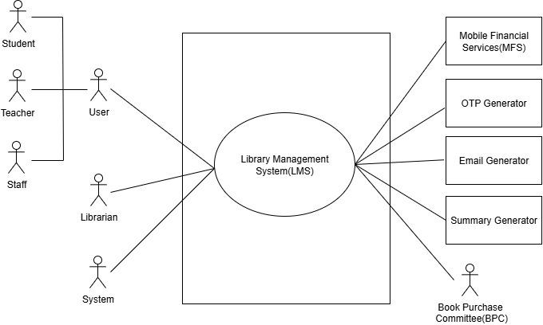

**Figure 1:** ISRT Library Management System (LMS) Use Case Diagram

## Level 1:

**Name:** ISRT Library Management System (LMS)  
**Primary Actor:** User (Student, Teacher, Staff), Librarian, System  
**Secondary Actors:** OTP Generator, Summary Generator, MFS (Mobile Financial Service), Email Generator, Book Purchase Committee (BPC)

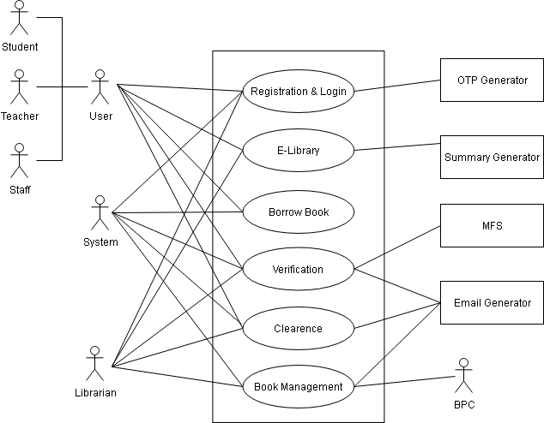

**Figure 2:** ISRT Library Management System (Detailed) Use Case Diagram

**Description:**

1. **Registration and Login:** Manages the creation and secure access of user accounts. Users register by selecting their role (Student, Teacher, or Staff), providing personal and role-specific details, and verifying their identity via OTP. After validation, they create a unique User ID and Password. The subsystem also handles login and password recovery via OTP.
2. **E-Library:** Offers a digital space where book PDFs, research journals, and academic resources are stored and accessible. Users can search for or browse books, download full PDFs, generate summaries, read research publications, and leave reviews and ratings, all while supporting self-paced learning and research engagement.
3. **Borrow Book:** Allows users to request physical books via two methods: manually filling out a form or selecting a book from the catalog. The subsystem forwards requests to the librarian for processing while capturing essential book and user details for tracking.
4. **Verification:** Handles librarian-side operations for borrowing requests. It checks book availability and user eligibility (including unpaid fines, blacklist status, and demerit points) before granting approval. Upon approval, the system generates a confirmation PDF with due dates, fine policy, and an official seal, sending it to the user via email.
5. **Clearance**: Enables users to request clearance certificates when needed (e.g., certificate, marksheet, or pension-related). The system verifies that there are no pending books, fines, or blacklist issues before generating and emailing a PDF clearance certificate. If requirements are not met, a cancellation notice is sent.
6. **Book Management:** Supports the management and growth of the library collection. The system analyzes borrowing trends and user demand to suggest books for purchase. A book purchase committee reviews these suggestions, makes final decisions, and manually verifies bills. The librarian then updates the system’s records to keep the catalog accurate and up to date.

## Level 1.1:

**Name:** Registration & Login  
**Primary Actor:** User (Student, Teacher, Staff), Librarian, System  
**Secondary Actors:** OTP Generator, Email Generator

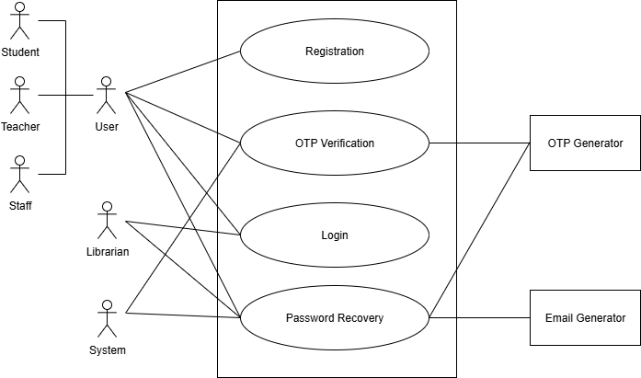

**Figure 3:** Registration & Login Use Case Diagram

**Description:**

1. **Registration:** New users, including students, teachers, and staff, begin by selecting their user type and providing their phone number along with required role-specific details, such as roll number, registration number, session, hall name, institutional email, and address for students, or designation, official email, and address for teachers and staff.
2. **OTP Verification:** An OTP is sent via the OTP Generator to the user’s registered phone number to confirm their identity; this process is used both during initial registration and for password recovery to ensure that only authorized users can access or modify their accounts. Successful verification allows the process to continue.
3. **Login:** After successful registration, users log in using their User ID and password. The system validates credentials and grants access to the role-specific dashboard.
4. **Password Recovery:** If a user forgets their password, they can enter their username and registered phone number to receive an OTP for identity verification. After verifying the OTP, they can set a new password, and the Email Generator sends a confirmation email to ensure account security.

## Level 1.2:

**Name:** E-library  
**Primary Actor:** User (Student, Teacher, Staff), Librarian, System  
**Secondary Actor:** Summary Generator

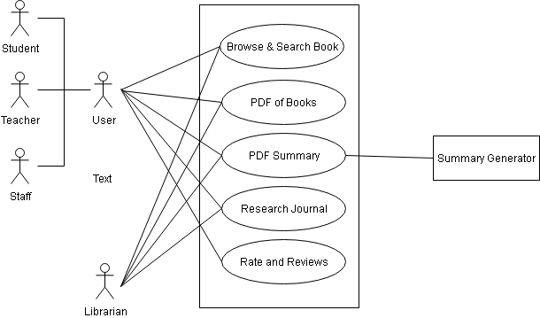

**Figure 4:** E-library Use Case Diagram

**Description:**

1. **Browse & Search Book:** Users and librarians can browse the library catalog or use smart search to find books by title, author, subject, etc., with filtering options.
2. **PDF of Books:** Users and librarians can access and download full digital copies of available books in PDF format from the E-Library.
3. **PDF Summary:** Allows users and librarians to download AI-generated summaries of books. The Summary Generator component powers this process.
4. **Research Journal:** It enables students, teachers, staff, and librarians to access published research journals authored by ISRT faculty and researchers. The librarian is responsible for uploading research journal PDFs to the system, ensuring that new publications are regularly added and made accessible to all authorized users for reading and reference
5. **Rate and Reviews:** Users (students, teachers, staff) can provide star ratings and write reviews on books they’ve read. Librarians may view these for quality assurance.

## Level 1.3:

**Name:** Borrow Book  
**Primary Actor:** User (Student, Teacher, Staff), System

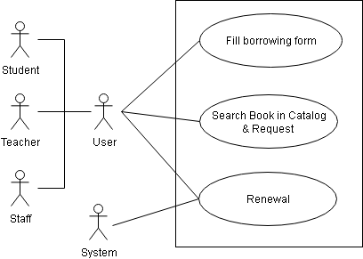

**Figure 5:** Borrow Book Use Case Diagram

**Description:**

1. **Fill Borrowing Form:** Users (students, teachers, staff) can manually fill out a borrowing request form by entering key book details such as title, author, and classification number. Alternatively, if a user selects a book from the catalog, the system auto-fills this form with the relevant data.
2. **Search Book in Catalog & Request:** Users can search for books using the library catalog, including a smart search feature that allows queries by title, author, classification number, or subject through text or voice input. The system also suggests books if the user enters nearly correct or partial information, helping to refine the search. Results can be further filtered for more precise browsing. Once users find a desired book, they can proceed to borrow it directly from its detail page.After completing the borrowing form either manually or via catalog auto-fill, users submit the request for processing. The system forwards the request to the librarian’s admin panel.
3. **Renewal**: Users can request to extend the return deadline of a borrowed book from their dashboard. The request is sent to the librarian for review. If approved, the system updates the due date and sends a new confirmation PDF to the user. Each user may renew a book up to two consecutive times. If no renewal is granted and the due date passes, the system automatically adds a demerit point.

## Level 1.4:

**Name:** Verification  
**Primary Actor:**  User (Student, Teacher, Staff), Librarian, System  
**Secondary Actor:** Email Generator, MFS

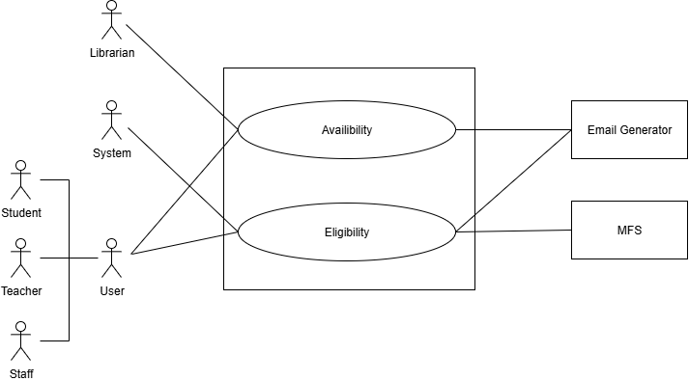

**Figure 6:** **Verification Use Case Diagram**

**Description:**

This use case manages the approval process for book borrowing. After a user submits a borrow request, the librarian initiates checks through the Availability and Eligibility subsystems. If books are available and the user meets all criteria (no fines, not blacklisted), the librarian approves the request and sets a custom return date. A confirmation PDF is generated and sent via email. If the request is denied, a cancellation notice is sent with the reason. Fines and penalties are handled through MFS integration

## Level 1.4.1:

**Name:** Availability  
**Primary Actor:** Librarian, System  
**Secondary Actor:** Email Generator

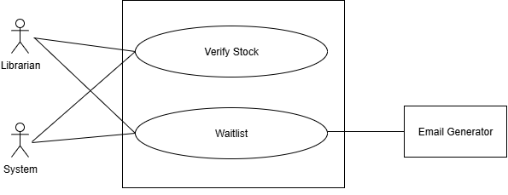

**Figure 7: Availability Use Case Diagram**

**Description:**

This subsystem verifies the real-time stock of requested books. The librarian can check whether copies are available or if the book is already on hold. If unavailable, the system adds the user to a waitlist queue, prioritizing teachers first, then others by request time. The Email Generator notifies users about status updates or waitlist placement.

## Level 1.4.2:

**Name:** Eligibility   
**Primary Actor:** User (Student, Teacher, Staff), System  
**Secondary Actor:** Email Generator, MFS

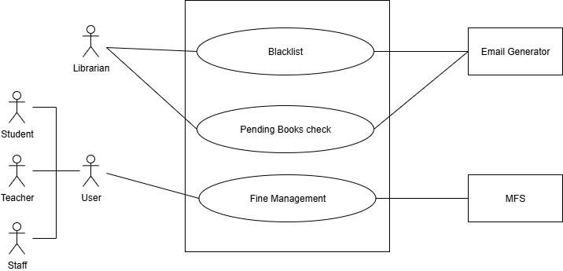

**Figure 8:** **Eligibility Use Case Diagram**

**Description:**

This use case verifies whether a user is eligible to borrow a book. It checks for unpaid fines, demerit points, or blacklist status. If the user fails any of these checks, the request is automatically rejected and a cancellation email is sent. Fine calculations and status updates are handled through MFS. Eligible users proceed to the final approval step.

## Level 1.5:

**Name:** Clearance  
**Primary Actor:** User (Student, Teacher, Staff), Librarian, System  
**Secondary Actor:** Email Generator

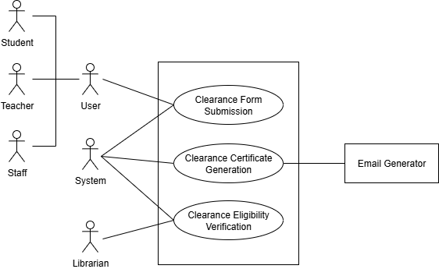

**Figure 9:** Clearance Use Case Diagram

**Description:**

1. **Clearance Form Submission:** Users (students, teachers, staff) submit a role-specific clearance form via their dashboard, providing necessary personal and institutional details. The request is forwarded for verification.
2. **Clearance Eligibility Verification:** The librarian checks if the user has pending books, unpaid fines, or blacklist status. Eligible users proceed; ineligible ones receive a rejection with reasons.
3. **Clearance Certificate Generation:** For eligible users, the system generates a PDF clearance certificate with user details and a library seal. It is emailed to the user via the Email Generator and added to their dashboard.

## Level 1.6:

**Name:** Book Management  
**Primary Actor:** Librarian  
**Secondary Actor:** BPC(Book Purchase Committee)

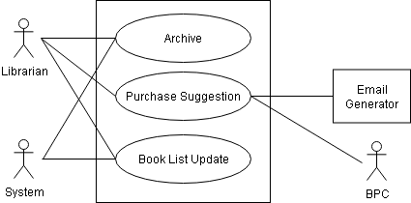

**Figure 10:** Update Book Record Use Case Diagram

**Description:**

1. **Purchase Suggestion:** Matches the data-driven recommendation system that supports the faculty book purchase committee.
2. **Book List Update:** The admin manually adds newly purchased books to the book list, entering all relevant details to make them available for users in the catalog. Similarly, any books that are damaged or no longer usable are deleted from the list to prevent future borrowing requests. This process maintains the reliability and quality of the library’s available resources.
3. **Archive**: Allows librarians to store records of removed or outdated books for internal reference and auditing, without displaying them in the active catalog.

# 5. Activity Diagram

Activity diagram is an important behavioral diagram in UML diagram to describe dynamic aspects of the system. Activity diagram is essentially an advanced version of flowchart that models the flow from one activity to another activity.

## Level 1.1:

**Name:** Registration & Login  
**Reference:** Use Case Diagram Level 1.1

|  |  |
| --- | --- |
| **https://lh7-rt.googleusercontent.com/docsz/AD_4nXfNiunzFs6bK0l3un61CkUJWskiJ9758T1PT7VeUZhjT0WtvO-sQ3LM5eP6sgJZxy57KAghcWrAmMXZnNuLwtfK-Rqh9rYdAEXs8eQME92dWyScPK6avoL0ChjDmuUqBiF7OLfXgxpMTBiX5ryWoSU?key=23u0T1OAyz5pxHQBC0E8LA** | **https://lh7-rt.googleusercontent.com/docsz/AD_4nXcrEai2OWlSE683Fxct0xi0h8VLEAZY5xPCyliwBVIR5nKyo481oQF-ADRDkyrNEWFwZHppKMg_uu2ld5O8G7dbyN0jkLEiEdpNXaPotK3QlkKdQzdMk8Ab6EUI-Nn0Bv7GI4UAP9Nsin-BZWPyUvw?key=23u0T1OAyz5pxHQBC0E8LA** |

|  |  |
| --- | --- |
| **https://lh7-rt.googleusercontent.com/docsz/AD_4nXe0eDk__FDdznGKuJCNjRI72Na76qVtjmE-i1im-aLPhaBhgp7cU6SE0v6zD1R5vxMEsm4I31iPGcEwV46-_g4RmRwPTlUwa0O45xrldPeLEcoqtyfpN1BWn-c96-J6juVj6NDC9mPwOnIffAmsgA?key=23u0T1OAyz5pxHQBC0E8LA** | **https://lh7-rt.googleusercontent.com/docsz/AD_4nXe-FcoAlMOg3w3cIMJ0yDUu-d9tE5ZMvVycmmnlTP6zbhvKmq-zyLZjsWf5-O-8vfvcHxCBFn6ivlUhtb85fDXL7Clu-wIyqBIImLcyJVT174e07VVfWbvpA_PXKhbwEXtE9nr7SvmtqfOCTtddsj4?key=23u0T1OAyz5pxHQBC0E8LA** |

## Level 1.2:

**Name:** E-library  
**Reference:** Use Case Diagram Level 1.2  
  
 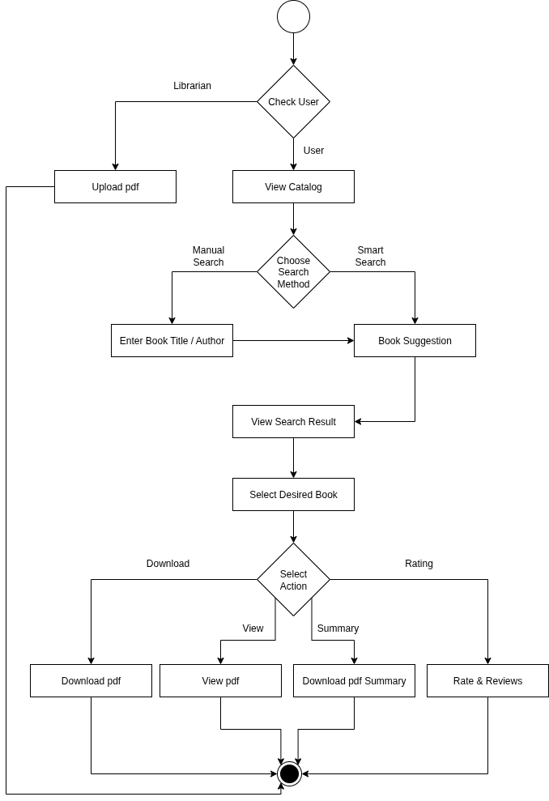

## Level 1.3:

**Name:** Borrow Book  
**Reference:** Use Case Diagram Level 1.3

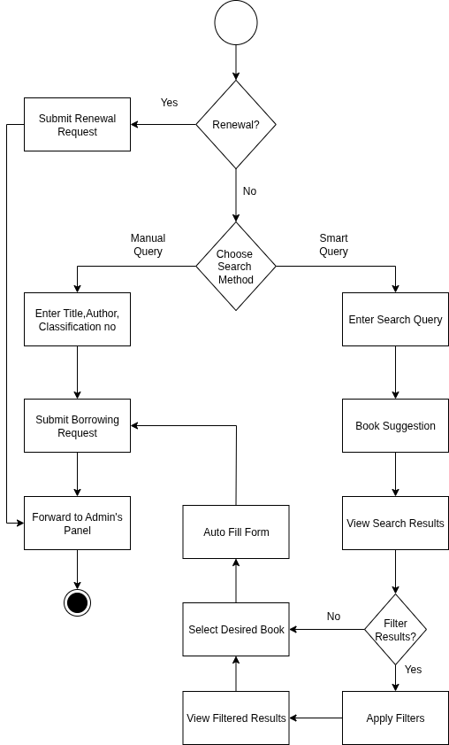

## Level 1.4:

**Name:** Verification  
**Reference:** Use Case Diagram Level 1.4

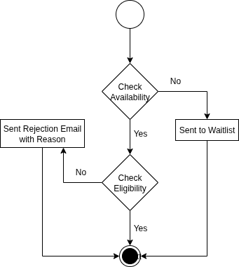

## Level 1.4.1:

**Name:** Availability  
**Reference:** Use Case Diagram Level 1.4.1  
  
 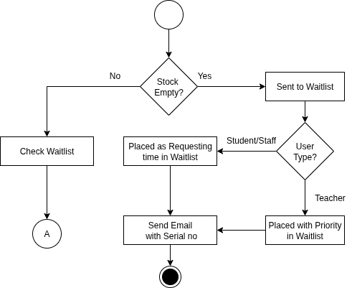

## Level 1.4.2:

**Name:** Eligibility  
**Reference:** Use Case Diagram Level 1.4.2

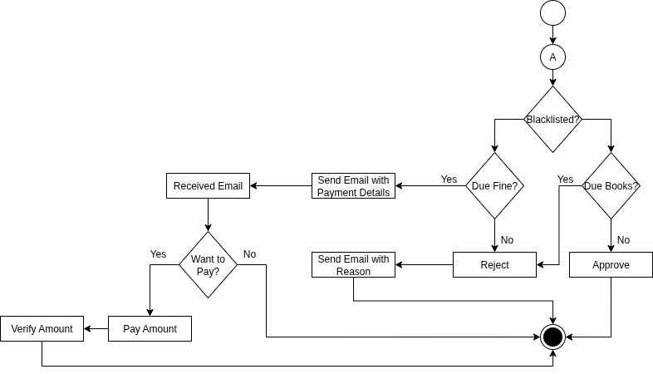

## Level 1.5:

**Name:** Clearance  
**Reference:** Use Case Diagram Level 1.5

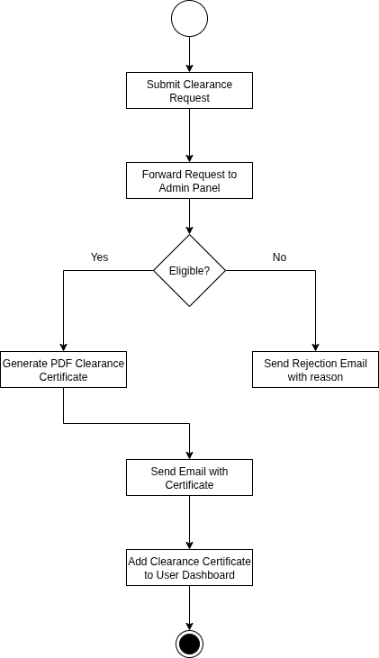

## Level 1.6:

**Name:** Book Management  
**Reference:** Use Case Diagram Level 1.6

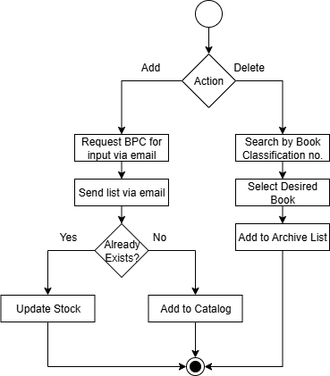

# 6. Swimlane Diagram

A Swimlane diagram is a type of flowchart, which diagrams a process from start to finish, but it also divides these steps into categories to help distinguish which departments or employees are responsible for each set of actions. It is based on the analogy of lanes in a pool, as it places process steps within the horizontal or vertical “Swimlanes” of a particular department, work group or employee, thus ensuring clarity and accountability.

## Level 1.1:

**Name:** Registration & Login  
**Reference:** Activity Diagram Level 1.1

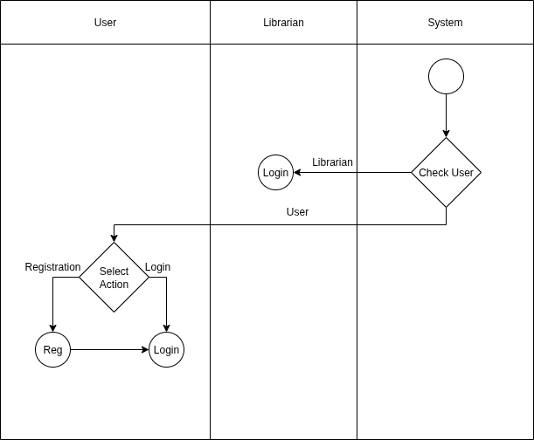

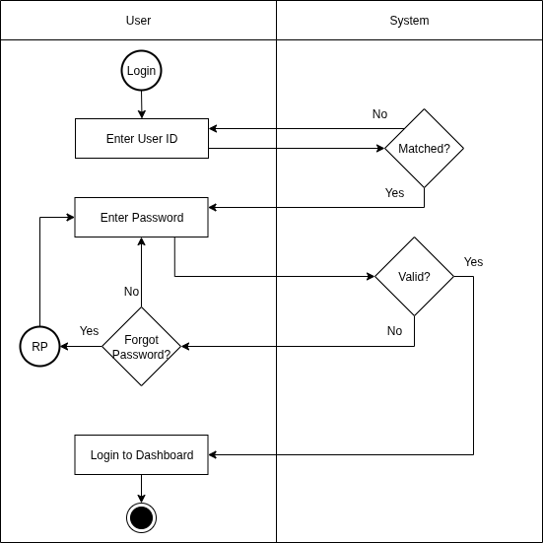

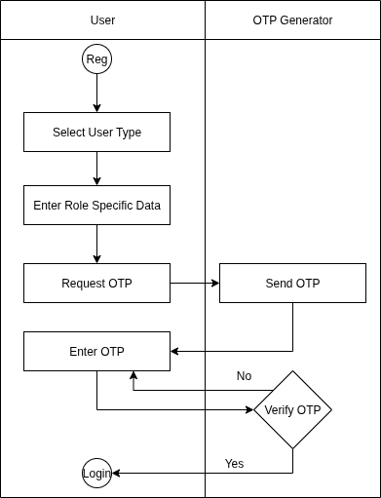

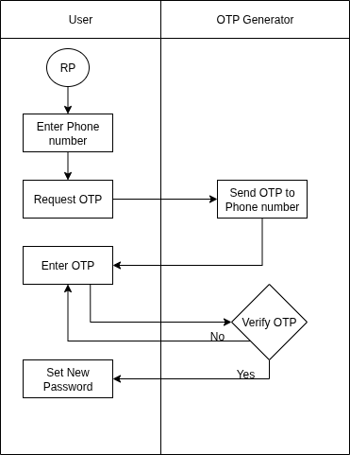

## Level 1.2:

**Name:** E-library  
**Reference:** Activity Diagram Level 1.2  
  
 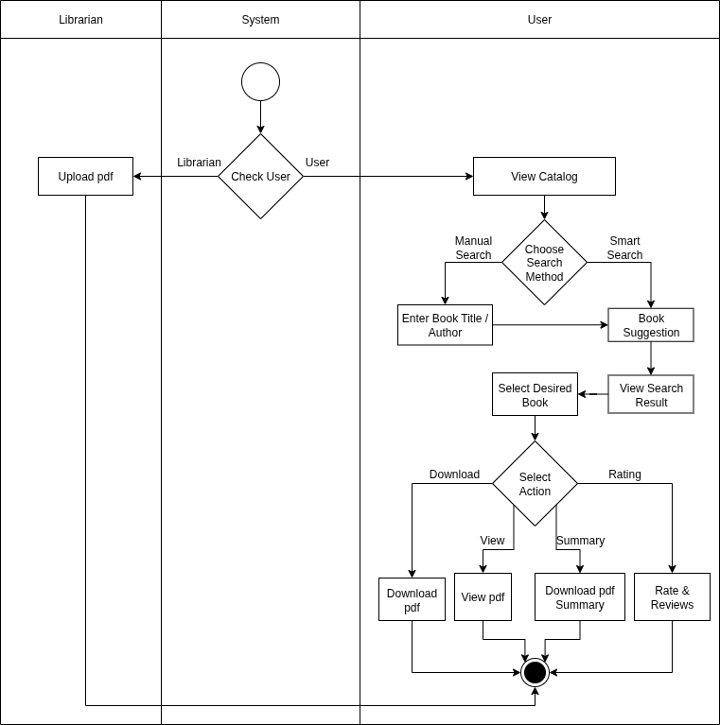

## Level 1.3:

**Name:** Borrow Book  
**Reference:** Activity Diagram Level 1.3  
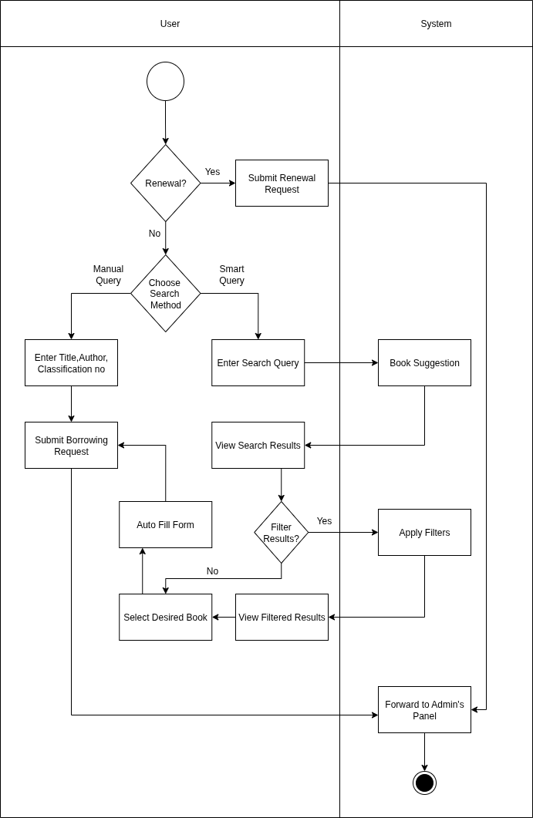

## Level 1.4.1:

**Name:** Availability  
**Reference:** Activity Diagram Level 1.4.1  
  
 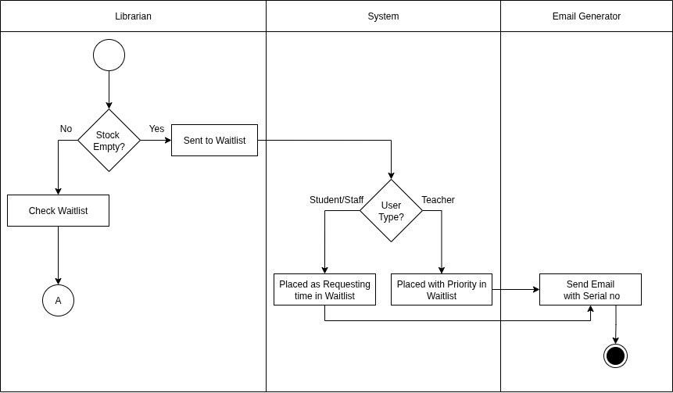

## Level 1.4.2:

**Name:** Eligibility  
**Reference:** Activity Diagram Level 1.4.2

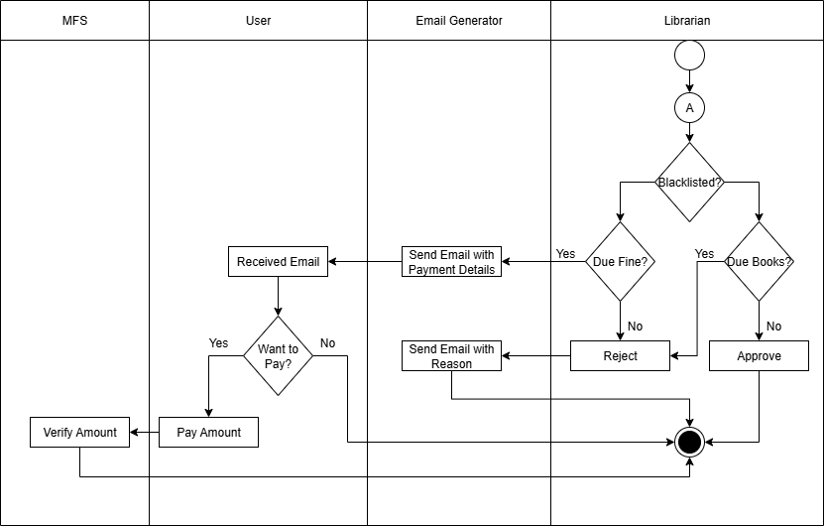

## Level 1.5:

**Name:** Clearance  
**Reference:** Activity Diagram Level 1.5

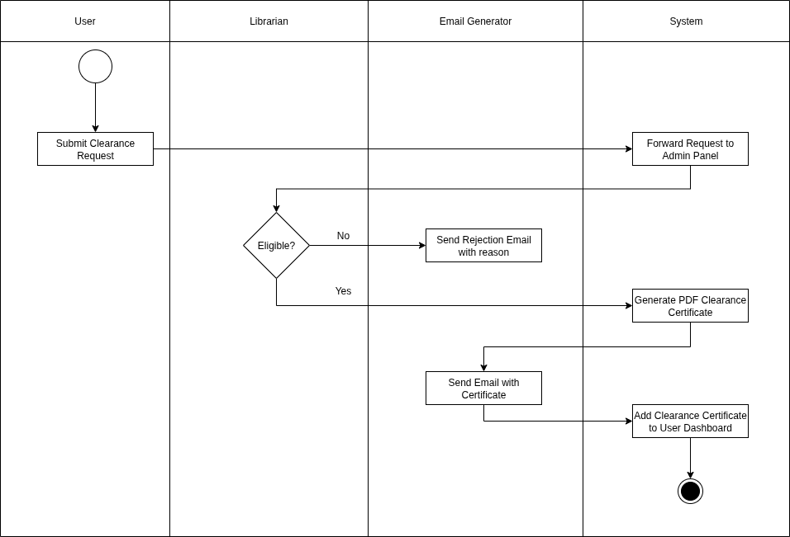

## Level 1.6:

**Name:** Book Management  
**Reference:** Activity Diagram Level 1.6

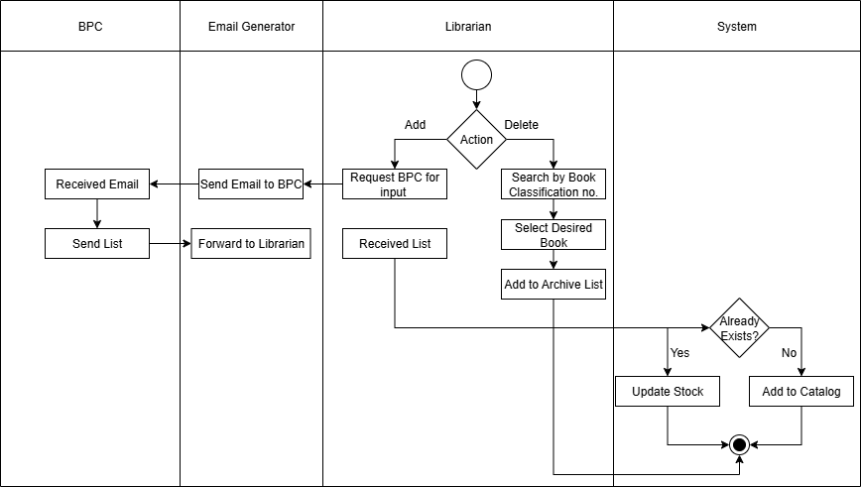

# 7. Data Based Modeling

## 7.1 Data Object Identification

|  |  |  |  |
| --- | --- | --- | --- |
| **No.** | **Noun** | **P / S** | **Attributes** |
| 1 | ISRT | P |  |
| 2 | Research Journal | P |  |
| 3 | Demand | P |  |
| 4 | Suggestion | P |  |
| 5 | Category | S |  |
| 6 | Annual budget | P |  |
| 7 | Bill | P |  |
| 8 | Accountability | P |  |
| 9 | Borrowing | S | 87, 45, 48, 15 |
| 10 | Internal reference | P |  |
| 11 | Researcher | P |  |
| 12 | Research | P |  |
| 13 | Output | P |  |
| 14 | Certificate | P |  |
| 15 | Date | S |  |
| 16 | Marksheet | P |  |
| 17 | Pension | P |  |
| 18 | Pending book | P |  |
| 19 | Statement | P |  |
| 20 | Mobile | P |  |
| 21 | Working duration | P |  |
| 22 | Metadata | P |  |
| 23 | Audit | P |  |
| 24 | Academic publishing | P |  |
| 25 | Account | P |  |
| 26 | Library Management System (LMS) | P |  |
| 27 | User | S | 32, 33, 40, 41, 44, 70, 80,91 |
| 28 | Student | S | 36, 37, 38, 39 |
| 29 | Teacher | S | 42, 89 |
| 30 | Staff | S | 42, 89 |
| 31 | Faculty | P |  |
| 32 | Name | S |  |
| 33 | Phone number | S |  |
| 34 | OTP | S | 33, 71, 15 |
| 35 | Verification | P |  |
| 36 | Roll number | S |  |
| 37 | Registration number | S |  |
| 38 | Session | S |  |
| 39 | Hall name | S |  |
| 40 | Email | S |  |
| 41 | Address | S |  |
| 42 | Designation | S |  |
| 43 | User ID | S |  |
| 44 | Password | S |  |
| 45 | Return date | S |  |
| 46 | Fine | S | 87, 103 |
| 47 | Payment | S | 33, 78,92 |
| 48 | Status | S |  |
| 49 | Notification | P |  |
| 50 | SMS | P |  |
| 51 | E-Library | P |  |
| 52 | Book PDF | S |  |
| 53 | Title | S |  |
| 54 | Author | S |  |
| 55 | Subject | S |  |
| 56 | Summary PDF | S |  |
| 57 | Review | S |  |
| 58 | Rating | S |  |
| 59 | Feedback | P |  |
| 60 | Smart search function | P |  |
| 61 | Filtering option | P |  |
| 62 | Borrowing request | P |  |
| 63 | Borrowing form | S |  |
| 64 | Classification number | S |  |
| 65 | Integrated library catalog | P |  |
| 66 | Availability | P |  |
| 67 | Waitlist | P |  |
| 68 | Eligibility | P |  |
| 69 | Queue | P |  |
| 70 | Role | S |  |
| 71 | Application time | S |  |
| 72 | Teacher priority | P |  |
| 73 | Return deadline | S |  |
| 74 | Fine policy | P |  |
| 75 | Library seal | P |  |
| 76 | Blacklist status | S |  |
| 77 | Cancellation notice | P |  |
| 78 | Mobile Financial Services (bKash, Nagad) | S |  |
| 79 | Transaction confirmation | P |  |
| 80 | Demerit point | S |  |
| 81 | Renewal | P |  |
| 82 | Borrowing record | P |  |
| 83 | Book purchase committee | P |  |
| 84 | Clearance | S | 48,76, 85, 86, 87, 14 |
| 85 | Request | P |  |
| 86 | Type | S |  |
| 87 | Form | S |  |
| 88 | Pending book | S |  |
| 89 | Department | S |  |
| 90 | Book | S | 52, 53, 54, 93, 94, 55, 64, 5,58,94 |
| 91 | Amount | S |  |
| 92 | Transaction ID | S |  |
| 93 | Price | S |  |
| 94 | Number of pages | S |  |
| 95 | Archive |  |  |

## 7.2 Data Objects:

|  |  |  |
| --- | --- | --- |
| No. | Data Objects | Attributes |
| 1 | User | Name, Phone no, Email, Address, User Id, Password, Role, Demerit Point, Amount |
| 2 | Student | Roll no, Registration no, Session, Hall |
| 3 | Teacher | Designation, Department |
| 4 | Staff | Designation, Department |
| 5 | Clearance | Status, Blacklist Status, Request, Type, Form, Certificate |
| 6 | Book | Book pdf, Title, Author, Number of Page, Price, Subject, Classification no, Category, Rating, Archive |
| 7 | Payment | Phone no, MFS, Transaction ID |
| 8 | OTP | OTP no, Phone no, Time, Date |
| 9 | Borrowing_Details | Borrow Id, Borrow Date, Form, Return date, Status |

## 7.3 Relations:

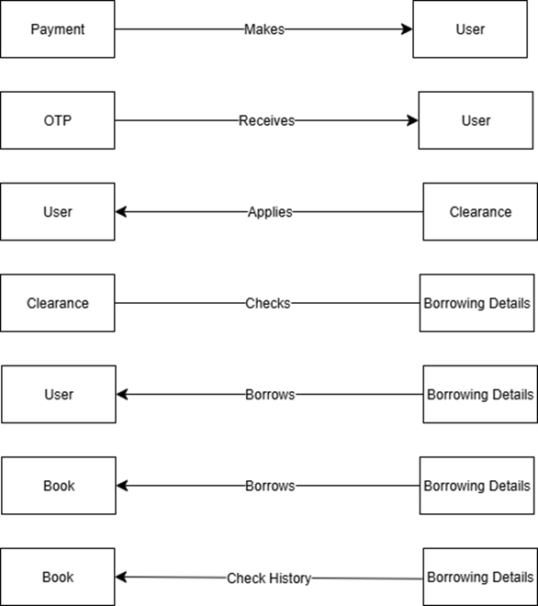

## 7.4 ERD:

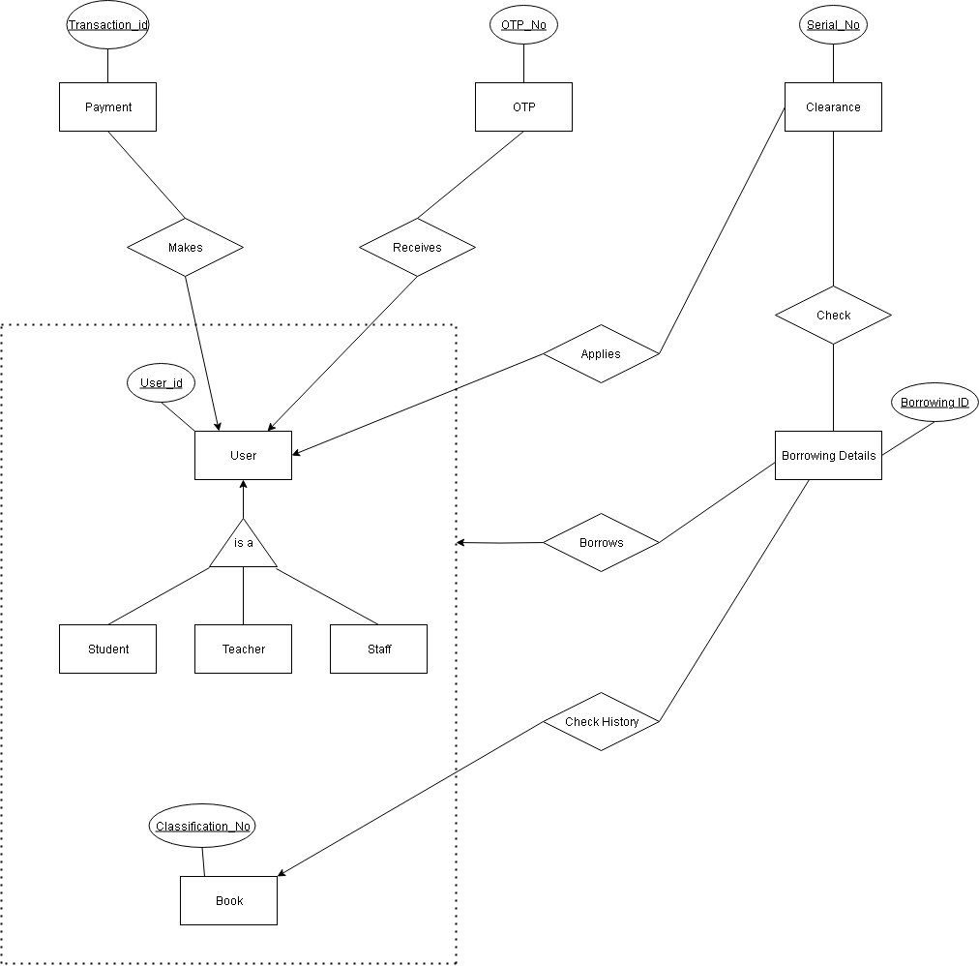

## 7.5 Schema:

|  |  |  |  |  |
| --- | --- | --- | --- | --- |
| No. | Entity Name | Attribute | Type | Description |
| 1. | User | User_Id (PK) | INT | Unique identifier for each user |
| Name | VARCHAR | Full name of the user |
| Phone_No | VARCHAR | User's phone number |
| Email | VARCHAR | User's email address |
| Address | VARCHAR | Residential address |
| Password | VARCHAR | Login password |
| Role | VARCHAR | Defines user type (Student, Teacher, Staff) |
| Demerit_Point | INT | Points deducted for violations |
| Amount | INT | Balance amount or dues |
| 2. | Student | User_Id (PK, FK) | INT | References User |
| Roll_No | VARCHAR | Student roll number |
| Registration_No | VARCHAR | Student registration number |
| Session | VARCHAR | Academic session |
| Hall | VARCHAR | Hall or dormitory name |
| 3 | Teacher | User_Id (PK, FK) | INT | References User |
| Designation | VARCHAR | Teacher's designation |
| Department | VARCHAR | Department of the teacher |
| 4 | Staff | User_Id (PK, FK) | INT | References User |
| Designation | VARCHAR | Staff designation |
| Department | VARCHAR | Staff department |
| 5 | Clearance | Serial_No (PK) | INT | Unique clearance number |
| User_Id (FK) | INT | References User |
| Status | VARCHAR | Clearance status |
| Blacklist_Status | BOOLEAN | Whether the user is blacklisted |
| Request | VARCHAR | Clearance request type |
| Type | VARCHAR | Type of clearance |
| Form | VARCHAR | Clearance form |
| Certificate | VARCHAR | Related certificate |
| 6 | Book | Classification_No (PK) | INT | Unique classification number |
| Title | VARCHAR | Book title |
| Author | VARCHAR | Book author |
| Subject | VARCHAR | Subject area |
| Book_PDF | VARCHAR | PDF file path or link |
| Category | VARCHAR | Book category |
| Rating | INT | Book rating |
| Price | DECIMAL | Price of a Book |
| Number_of_page | INT | Number of pages of a book |
| Archive | BOOLEAN | Whether book is archived |
| 7 | Payment | Transaction_Id (PK) | INT | Unique transaction identifier |
| User_Id (FK) | INT | References User |
| Phone_No | VARCHAR | Payment phone number |
| MFS | VARCHAR | Mobile financial service used |
| 8 | OTP | OTP_No (PK) | INT | One-time password identifier |
| User_Id (FK) | INT | References User |
| Phone_No | VARCHAR | User's phone number |
| Time | VARCHAR | OTP generation time |
| Date | DATE | OTP generation date |
| 9 | Borrowing_Details | Borrow_Id (PK) | INT | Unique borrow identifier |
| User_Id (FK) | INT | References User |
| Classification_No (FK) | INT | References Book |
| Borrow_Date | DATE | Borrowing date |
| Return_Date | DATE | Book return date |
| Status | VARCHAR | Status of Borrowing |
| 10 | Check | Serial_No (PK, FK) | INT | References Clearance |
| Borrow_Id (PK, FK) | INT | References Borrowing_Details |

# 8. Class Based Modeling

Class-based modeling defines the structure of the entire system by identifying the static structure of objects in that system. A class model defines attributes and operations for the objects of each class and also the relationship between the objects, and the collaborations that occur between the classes of the systems. The elements of a class-based model include classes and objects, attributes, operations, Class- Responsibility- Collaborator (CRC) models, collaboration diagrams, and packages.

## 8.1 General Characteristics

Candidate classes are categorized based on the seven general classification. The analysis classes manifest themselves in one of the following ways:

1. External Entities
2. Things
3. Occurrence/Events
4. Organizational Unit
5. Role
6. Places
7. Structures

A candidate class is selected for special classification if it fulfills three or more characteristics.

**List of Nouns:**

|  |  |  |  |
| --- | --- | --- | --- |
| **Sl. No.** | **Noun** | **P / S** | **General Classification** |
| 1. | Library Management System (LMS) | S | 4 |
|  | User | S | 4,5,7 |
|  | Student | S | 4,5,7 |
|  | Teacher | S | 4,5,7 |
|  | Staff | S | 4,5,7 |
|  | Name | S | 2 |
|  | Phone number | S | 2 |
|  | OTP | S | 1 |
|  | Verification | S | 3 |
|  | Roll number | S | 2 |
|  | Registration number | S | 2 |
|  | Session | S | 2 |
|  | Hall | S | 6 |
|  | Email | S | 1 |
|  | Address | S | 6 |
|  | Designation | S | 2 |
|  | User ID | S | 2 |
|  | Password | S | 2 |
|  | Account | S | 2 |
|  | Due date | S |  |
|  | Fine | S |  |
|  | Payment | S | 3 |
|  | Status | S |  |
|  | Notification | S |  |
|  | SMS | S |  |
|  | E-Library | S |  |
|  | Book PDF | S |  |
|  | Title | S |  |
|  | Author | S | 5 |
|  | Subject | S |  |
|  | Summary PDF | S |  |
|  | Review | S |  |
|  | Rating | S |  |
|  | Feedback | S |  |
|  | Smart search function | S |  |
|  | Filtering option | S |  |
|  | Borrowing request | S |  |
|  | Borrowing form | S |  |
|  | Classification number | S | 2 |
|  | Integrated library catalog | S | 2 |
|  | Book information | S |  |
|  | Availability | S |  |
|  | Waitlist | S |  |
|  | Eligibility | S |  |
|  | Approval | S |  |
|  | Real-time stock | S |  |
|  | Queue | S |  |
|  | Role | S |  |
|  | Application time | S |  |
|  | Teacher priority | S |  |
|  | Category | S |  |
|  | Return deadline | S |  |
|  | Fine policy | S |  |
|  | Library seal | S |  |
|  | Blacklist status | S |  |
|  | Cancellation notice | S |  |
|  | Mobile Financial Services (bKash, Nagad) | S | 1 |
|  | Transaction confirmation | S |  |
|  | Demerit point | S | 2 |
|  | Outstanding fine | S | 2 |
|  | Reactivation | S | 3 |
|  | Renewal | S | 3 |
|  | Borrowing record | S |  |
|  | Book purchase committee | S | 4 |
|  | Clearance | S | 3, 7 |
|  | Request | S |  |
|  | Type | S |  |
|  | Form | S |  |
|  | Certificate | S |  |
|  | Marksheet | S |  |
|  | Pension | S |  |
|  | Pending book | S |  |
|  | Department | S |  |
|  | Book | S | 2, 4, 7 |
|  | Amount | S |  |
|  | Transaction ID | S |  |
|  | Payment | S | 3,7 |
|  | OTP | S | 1, 2, 3, 7 |
|  | Admin | S | 4, 5, 7 |
|  | BPC | S | 1 |

### Possible Classes:

1. User
2. Student
3. Teacher
4. Staff
5. MFS
6. OTP
7. Book
8. Admin
9. EmailGenerator
10. SummaryGenerator
11. BPC

## 8.2 Selection Criteria:

1. Retained Information
2. Needed Service
3. Multiple Attributes
4. Common Operation
5. Common Attributes
6. Essential Requirements

|  |  |  |
| --- | --- | --- |
| **No** | **Classes** | **Selection Criteria** |
| 1. | User | 1, 3, 5, 6 |
| 2. | Student | 1, 3, 5, 6 |
| 3. | Teacher | 1, 3, 5, 6 |
| 4. | Staff | 1, 3, 5, 6 |
| 5. | MFS | 6 |
| 6. | OTP | 6 |
| 7. | Book | 1, 2, 3, 6 |
| 8. | Admin | 1, 3, 6 |
| 9. | EmailGenerator | 6 |
| 10. | SummaryGenerator | 6 |
| 11. | BPC | 6 |

### Analysis:

We can remove “Student, Teacher, Staff” class because all attributes and responsibilities can be found in “User” class.

## 8.3 List of Verbs:

|  |  |  |  |
| --- | --- | --- | --- |
| No | Verbs | No | Verbs |
| 1. | Begin | 41. | View |
| 2. | Select | 42. | Borrow |
| 3. | Register | 43. | Activity |
| 4. | Provide | 44. | Ensure |
| 5. | Submit | 45. | Request |
| 6. | Sent | 46. | Need |
| 7. | Verify | 47. | Browse |
| 8. | Enter | 48. | Search |
| 9. | Create | 49. | Download |
| 10. | Access | 50. | Participate |
| 11. | Grant | 51. | Review |
| 12. | Complete | 52. | Leave |
| 13. | Login | 53. | Offer |
| 14. | Recognize | 54. | Engage |
| 15. | Forget | 55. | Promote |
| 16. | Recover | 56. | Encourage |
| 17. | Allow | 57. | Enable |
| 18. | Reset | 58. | Find |
| 19. | Confirm | 59. | Filter |
| 20. | Initiate | 60. | Fill out |
| 21. | Find | 61. | Display |
| 22. | Click | 62. | Forward |
| 23. | Process | 63. | Check |
| 24. | Redirect | 64. | Reject |
| 25. | Cancel | 65. | Receive |
| 26. | Reserve | 66. | Hold |
| 27. | Ensure | 67. | Move |
| 28. | Add | 68. | Place |
| 29. | Give | 69. | Organize |
| 30. | Monitor | 70. | Notify |
| 31. | Return | 71. | Align |
| 32. | Include | 72. | Save |
| 33. | Meet | 73. | Pay |
| 34. | Update | 74. | Settle |
| 35. | Clear | 75. | Approve |
| 36. | Renewal | 76. | Handle |
| 37. | Analyze | 77. | Depend |
| 38. | Remove | 78. | Publish |
| 39. | Apply | 79. | Appear |
| 40. | Contain |  |  |

## Selected Classes:

**1. User**

**a. Attributes:**

* Name
* Phone No
* Email
* Address
* User Id
* Password
* Role
* Demerit Point
* Amount

**b. Methods:**

* register()
* login()
* recoverPassword()
* updateProfile()
* submitClearanceRequest()
* borrowBook()
* payFine()
* receiveNotification()

**2. Admin**

**a. Attributes:**

* Name
* Phone No
* Email
* adminId
* Password

**b. Methods:**

* approveBorrowRequest()
* rejectBorrowRequest()
* approveClearance()
* rejectClearance()
* setReturnDeadline()
* uploadResearchJournal()
* addBook()
* updateBook()
* deleteBook()
* verifyPurchaseBills()

**3. Book**

**a. Attributes:**

* bookId
* title
* author
* subject
* classificationNo
* category
* rating
* bookPDF
* archived

**b. Methods:**

* searchBook()
* viewDetails()
* downloadPDF()
* updateAvailability()
* archiveBook()
* addRating()

**4. MFS (Mobile Financial Service)**

**a. Attributes:**

* transactionId
* phoneNo
* serviceName

**b. Methods:**

* processPayment()
* verifyTransaction()
* notifyUser()

**5. OTP**

**a. Attributes:**

* otpNo
* phoneNo
* time
* date

**b. Methods:**

* generateOTP()
* sendOTP()
* verifyOTP()
* expireOTP()

**6. EmailGenerator**

**a. Attributes:**

* email
* date

**b. Methods:**

* sendAccountEmail()
* sendBorrowingEmail()
* sendClearanceEmail()
* sendNotificationEmail()

**7. SummaryGenerator**

**a. Attributes:**

* pdf
* bookTitle

**b. Methods:**

* generateSummary()
* exportSummaryPDF()
* saveSummary()

**8. BPC**

**a. Attributes:**

* members
* budget
* committeeId
* bookList

**b. Methods**

* reviewSuggestion()
* updateCommittee()
* updateBookList()

## 8.4 CRC:

1. **User**

|  |  |
| --- | --- |
| **Attributes** | **Methods** |
| Name  Phone No  Email  Address  User Id  Password  Role  Demerit Point  Amount | register()  login()  recoverPassword()  updateProfile()  submitClearanceRequest()  borrowBook()  payFine()  rateBook() |
| **Responsibilities** | **Collaborator** |
| Register and log in with role-specific details | Admin |
| Recover password using OTP | OTP |
| Pay fines via MFS | MFS |
| Request clearance (certificate, marksheet, pension) | Admin |

**2. Admin**

|  |  |
| --- | --- |
| **Attributes** | **Methods** |
| name  phoneNo  email  adminId  password | approveBorrowRequest()  rejectBorrowRequest()  approveClearance()  rejectClearance()  setReturnDeadline()  uploadResearchJournal()  addBook()  updateBook()  deleteBook()  verifyPurchaseBills() |
| **Responsibilities** | **Collaborator** |
| Approve/reject borrow requests | User |
| Add, update, or delete book records | Book |
| Verify bills for purchased books | MFS, OTP |

**3. Book**

|  |  |
| --- | --- |
| **Attributes** | **Methods** |
| bookId  title  author  subject  classificationNo  category  rating  bookPDF  archived | searchBook()  viewDetails()  downloadPDF()  updateAvailability()  archiveBook()  addRating() |
| **Responsibilities** | **Collaborator** |
| Maintain book metadata | Admin |
| Provide PDF downloads | SummaryGenerator |

**4. MFS**

|  |  |
| --- | --- |
| **Attributes** | **Methods** |
| transactionId  phoneNo  serviceName | processPayment()  verifyTransaction()  notifyUser() |
| **Responsibilities** | **Collaborator** |
| Process payments (fines, fees) | User |
| Verify transaction IDs | Admin |
| Notify users of successful or failed payments | User |

**5. OTP**

|  |  |
| --- | --- |
| **Attributes** | **Methods** |
| otpNo  phoneNo  time  date | generateOTP()  sendOTP()  verifyOTP() |
| **Responsibilities** | **Collaborators** |
| Generate & send OTP for registration and password recovery | User |
| Verify OTP for authentication | Admin |

**6. EmailGenerator:**

|  |  |
| --- | --- |
| **Attributes** | **Methods** |
| Email  Date | sendAccountEmail()  sendBorrowingEmail()  sendClearanceEmail()  sendNotificationEmail() |
| **Responsibilities** | **Collaborators** |
| Send account-related emails | User |
| Send borrowing approval/rejection | Admin |
| Send clearance approval/rejection | User, Admin |
| Send due/fine notifications | User |
| Log email with date | OTP, MFS, SummaryGenerator |

**7. BPC**

|  |  |
| --- | --- |
| **Attributes** | **Methods** |
| members  budget  committeeId  bookList | reviewSuggestion()  updateCommittee()  updateBookList() |
| **Responsibility** | **Collaborator** |
| verifies bills | Admin |
| Give book list | Admin |

**8. Summary Generator**

|  |  |
| --- | --- |
| **Attributes** | **Methods** |
| pdf  bookTitle | generateSummary()  exportSummaryPDF()  saveSummary() |
| **Responsibility** | **Collaborator** |
| Generates summary of book or journal | User |

## 8.5 CRC Diagram:

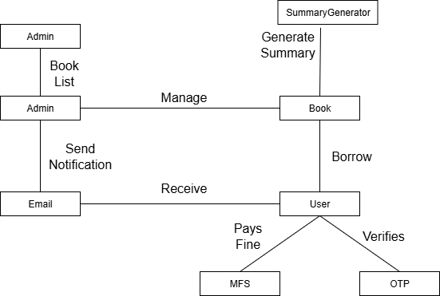

**Figure 42:** Class Responsibility Collaborator Diagram

# 9. Behavioral Modeling

## 9.1 Introduction

The behavioral model predicts how the software will react to events or stimuli outside its control. Two distinct characterizations of states must be taken into account while modeling behavior: (1) the state of each class as the system executes its function, and (2) the state of the system as seen from the outside as the system executes its function.

## 9.2 State Transition

### List of Events:

| **No** | **Initiator** | **Event** | **Event Name** | **Collaborator** |
| --- | --- | --- | --- | --- |
| 01 | Admin | Enter classification no, title, author | Add Book to Catalog | Book |
| 02 | Admin | Enter classification no to search | Check Book Availability | Book |
| 03 | User | Provide registration details | User Registration | OTP |
| 04 | User | Enter user id, password | User Login | Admin |
| 05 | User | Enter classification no/title | Search Book | Book |
| 06 | User | Submit clearance application | Clearance Request Submitted | Admin |
| 07 | User | Pay fine via MFS | Fine Payment | MFS |
| 08 | User | Enter book title for PDF | Request PDF Download | Book |
| 09 | MFS | Complete transaction | Payment Confirmed | User |
| 10 | OTP | Generate and send OTP | OTP Sent | User |
| 11 | EmailGenerator | Send confirmation/fine/clearance email | Notification Sent | User |
| 12 | Admin | Enter admin id, password | Admin Login | Admin |
| 13 | Admin | Upload book PDF/journal | E-Library Update | Book |
| 14 | BPC | Send approved book list | Book List Submitted | Admin |
| 15 | Admin | Approve clearance request | Clearance Approved | EmailGenerator |
| 16 | Admin | Reject clearance request | Clearance Rejected | User |
| 17 | Admin | Approve borrow request, set deadline | Borrow Approved | User |
| 18 | Admin | Reject borrow request | Borrow Rejected | User |
| 19 | User | Return borrowed book | Book Returned | Admin |
| 20 | Admin | Update book status after return | Availability Updated | Book |
| 21 | User | Submit rating/review | Book Rated | Book |
| 22 | SummaryGenerator | Generate summary PDF | Summary Created | User |
| 23 | User | Request renewal | Renewal Requested | Admin |
| 24 | Admin | Approve renewal (within limit) | Renewal Approved | EmailGenerator |
| 25 | Admin | Reject renewal | Renewal Rejected | User |
| 26 | System | Trigger before deadline | Reminder Sent | EmailGenerator |
| 27 | Admin | Archive old/damaged book | Book Archived | Book |
| 28 | Admin | Verify purchase bills | Bills Verified | BPC |
| 29 | User | Update personal profile | Profile Updated | Admin |
| 30 | Admin | Assign budget for book purchase | Budget Allocated | BPC |
| 31 | BPC | Review borrowing trends and demand | Suggest Books | Admin |
| 32 | Admin | Delete a book record | Book Deleted | Book |
| 33 | User | Request account reactivation | Reactivation Requested | Admin |
| 34 | Admin | Verify fines and overdue books | Reactivation Verified | User |
| 35 | Admin | Approve reactivation | Reactivation Approved | User |
| 36 | Admin | Reject reactivation | Reactivation Rejected | User |
| 37 | User | Forget password and enter phone no | Password Recovery Started | OTP |
| 38 | OTP | Verify OTP for password reset | OTP Verified | User |
| 39 | User | Set new password | Password Reset | Admin |
| 40 | EmailGenerator | Send password reset confirmation | Password Reset Email Sent | User |
| 41 | System | Add demerit point after missed deadline | Demerit Assigned | User |
| 42 | User | View borrowed book list | Borrowed List Viewed | Admin |
| 43 | Admin | Upload research journal | Research Journal Added | Book |
| 44 | User | View research journal | Journal Accessed | Book |
| 45 | User | Log out | User Logged Out | Admin |
| 46 | Admin | Log out | Admin Logged Out | Admin |

### 9.2.1 User

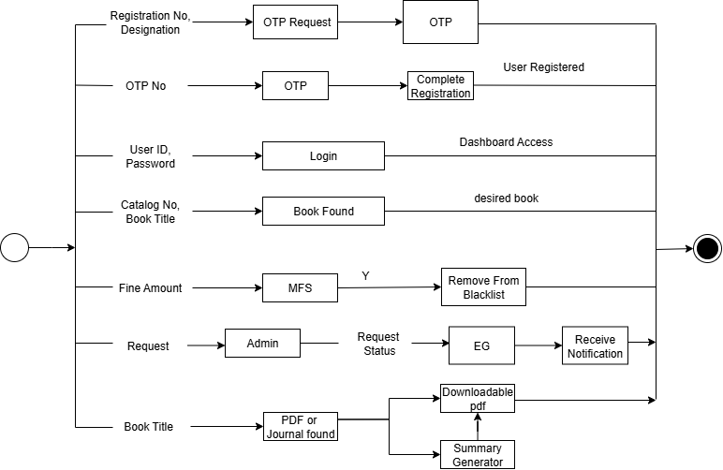

**Figure 43:** State Transition of User Class

### 9.2.2 OTP

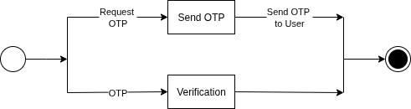

**Figure 44:** State Transition of OTP Class

### 9.2.3 MFS



**Figure 45:**  State Transition of MFS Class

### 9.2.4 EmailGenerator



**Figure 46:**  State Transition of EmailGenerator Class

### 9.2.5 Admin

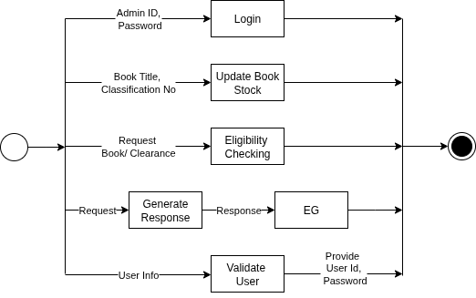

**Figure 47:** State Transition of Admin Class

### 9.2.6 Book

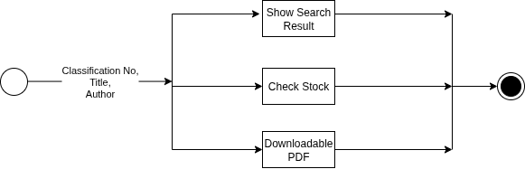

**Figure 48:** State Transition of Book Class

### 9.2.7 BPC



**Figure 49:** State Transition of BPC Class

### 9.2.8 SummaryGenerator



**Figure 50:**  State Transition of SummaryGenerator Class

## 9.3 Sequence Diagram

The second type of behavioral representation, called a sequence diagram in UML, represents how events cause flow from one object to another as a function of time. The sequence diagram is a shorthand version of the use case. It represents vital classes and the events that cause behavior to flow from class to class.

## 9.3.1 Purpose of Sequence Diagram

● High-level interaction between active objects in a system

● The interaction between object instances within a collaboration that

realizes a use case

● The interaction between objects within a collaboration that realizes an operation

● Either model generic interactions (showing all possible paths through the interaction)

or specific instances of an interaction (showing just one path through the interaction)

## 9.3.2 Sequence Diagram of LMS

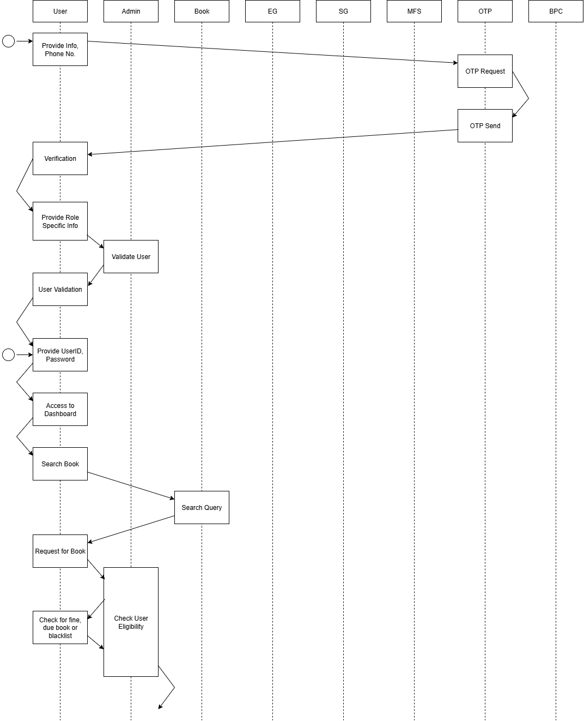

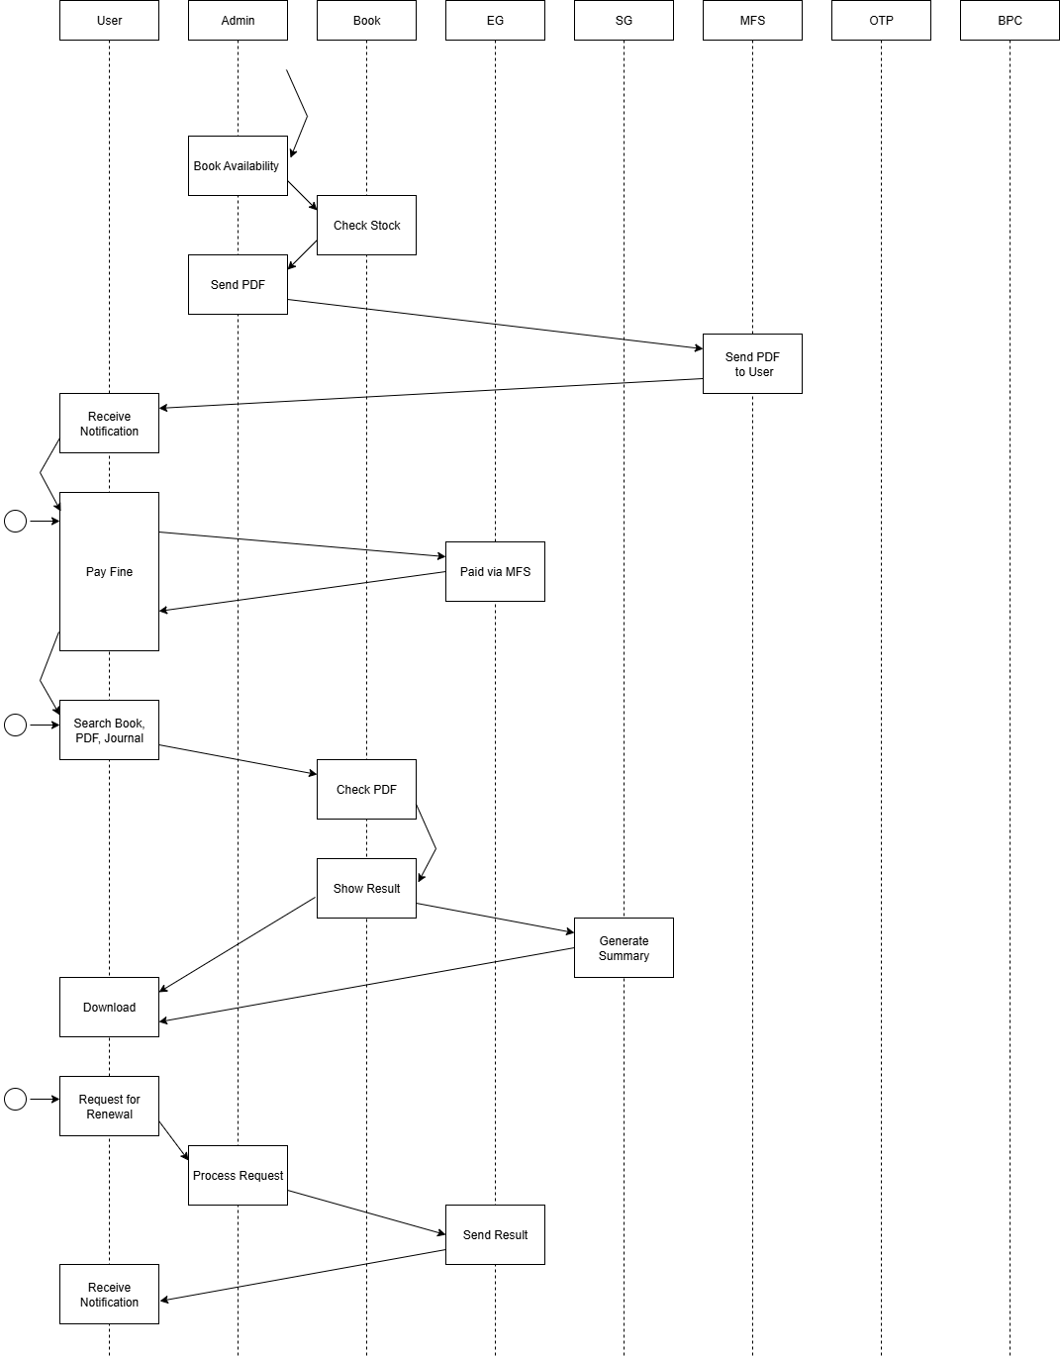

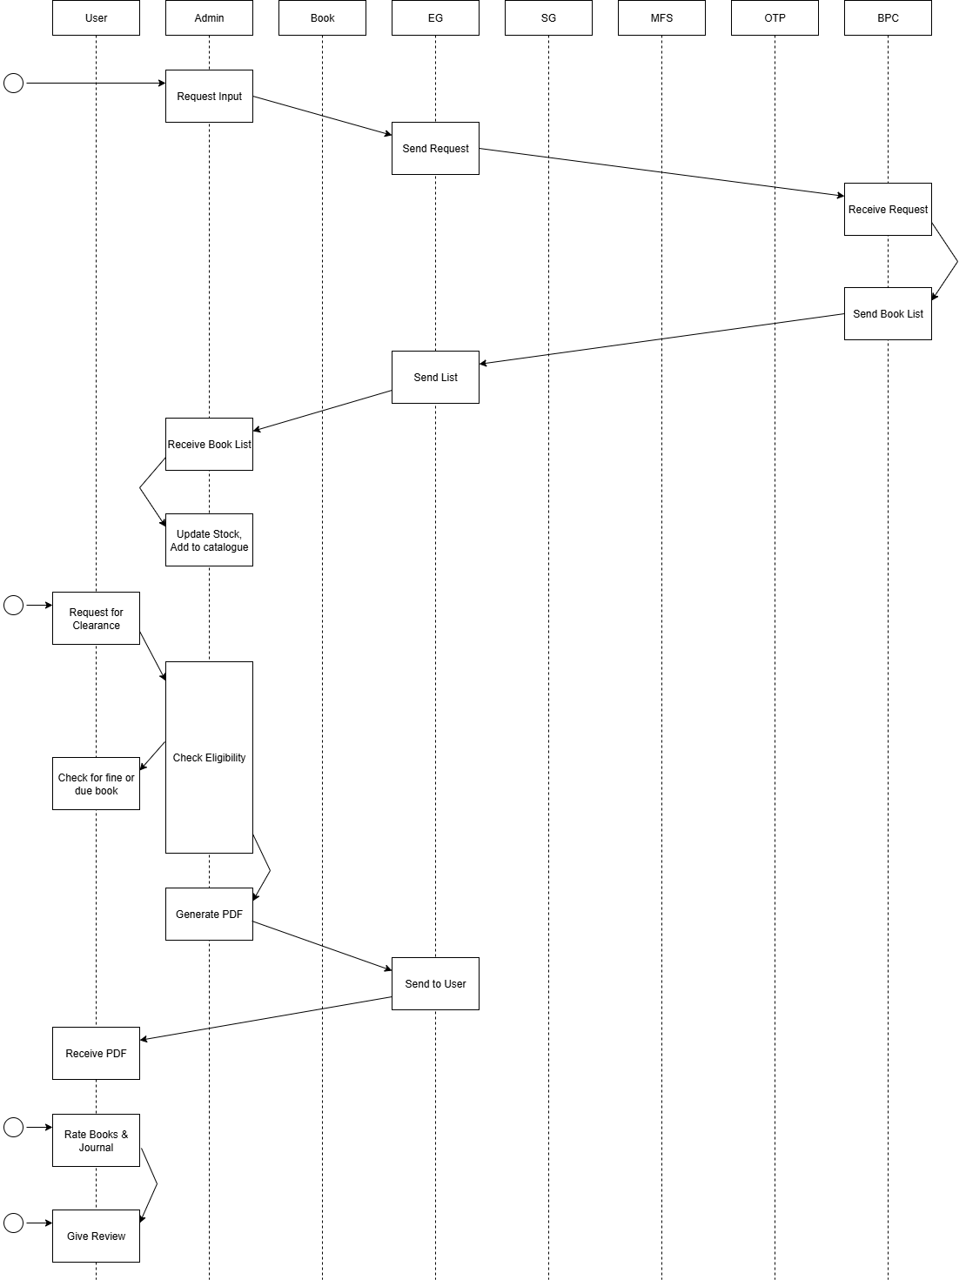

**Figure 51:** Sequence Diagram

# 10. Data Flow Diagram

A data flow diagram (DFD) is a graphical representation of the "flow" of data through

an information system, modeling its process aspects. A DFD is often used as a

preliminary step to create an overview of the system without going into great detail,

which can later be elaborated.

## Level 0:

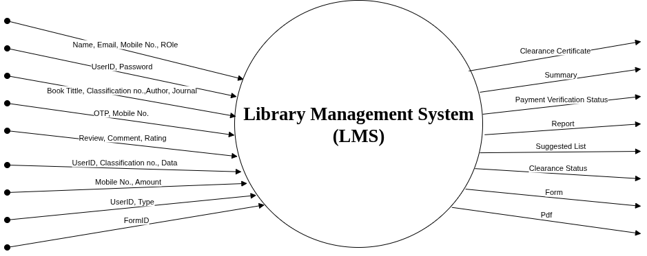

**Figure 52:** DFD of Level 0

## Level 1:

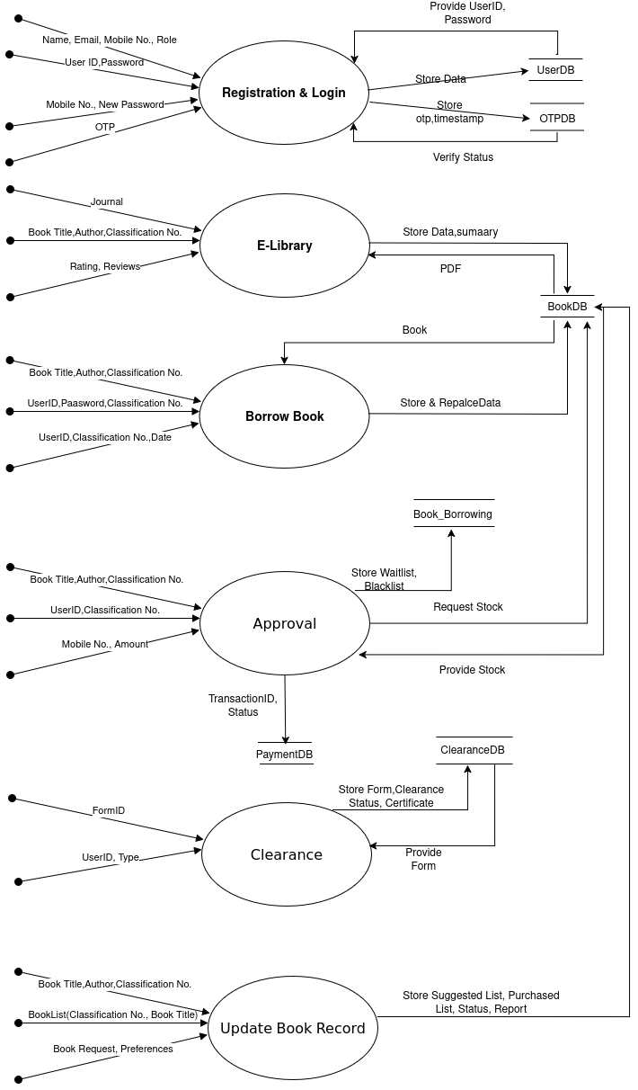

**Figure 53:**  DFD of Level 1

## Level 1.1:

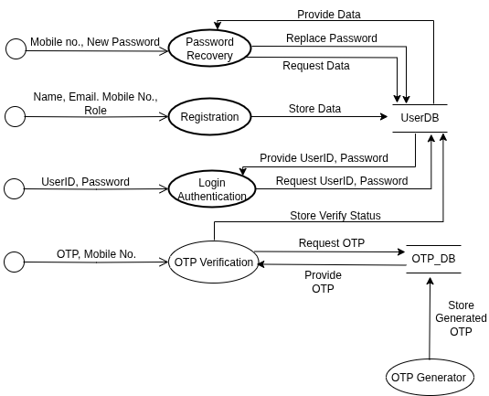

**Figure 54: DFD of Level 1.1**

## Level 1.2:

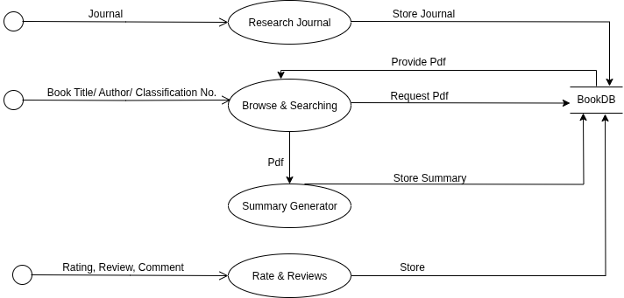

**Figure 55: DFD of Level 1.2**

## Level 1.3:

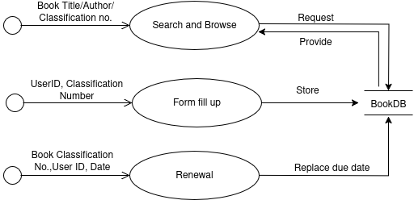

**Figure 56: DFD of Level 1.3**

## Level 1.4:

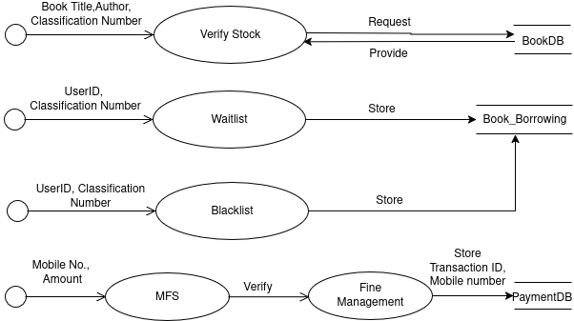

**Figure 57:** DFD of Level 1.4

## Level 1.5:

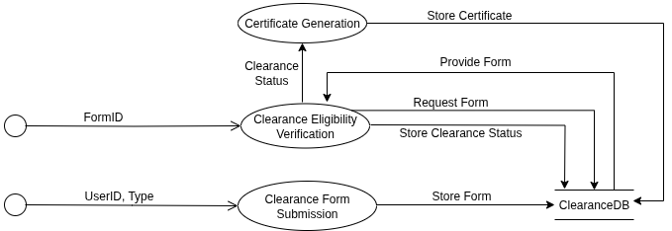

**Figure 58:** DFD of Level 1.5

## Level 1.6:

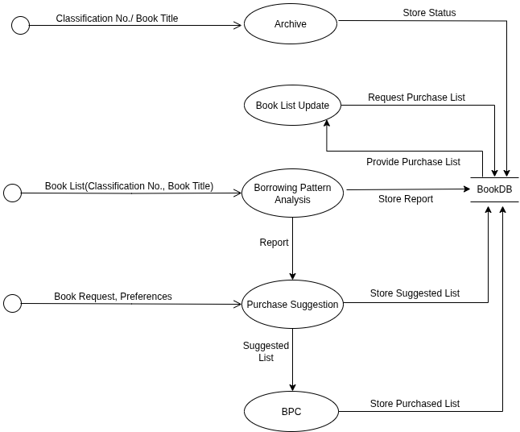

**Figure 59:** DFD of Level 1.6